**Naïve Bayes Report**

**Classification and Evaluation**

**Accuracies for different ALPHA**

|  |  |
| --- | --- |
| **ALPHA** | **Accuracy** |
| **0.1** | **81.92%** |
| **0.5** | **82.90%** |
| **1.0** | **83.22%** |
| **5.0** | **83.20%** |
| **10.0** | **83.03%** |

**When ALPHA = 0.1**

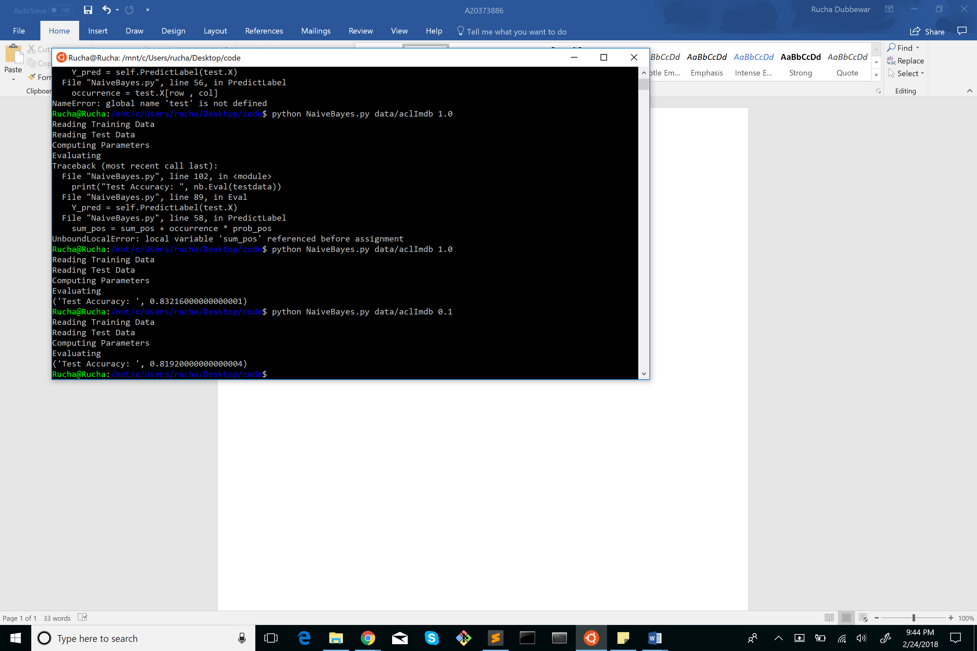

**When ALPHA = 0.5**

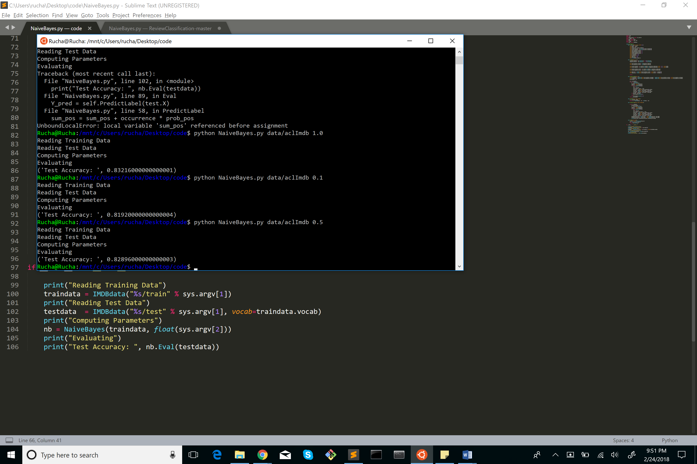

**When ALPHA = 1.0**



**When ALPHA = 5.0**

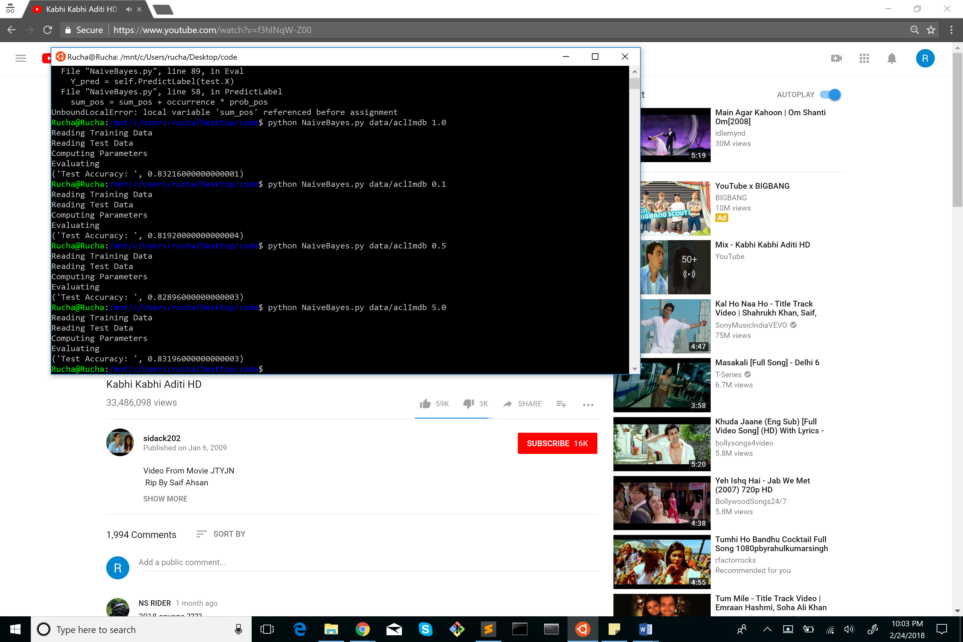

**When ALPHA = 10.0**

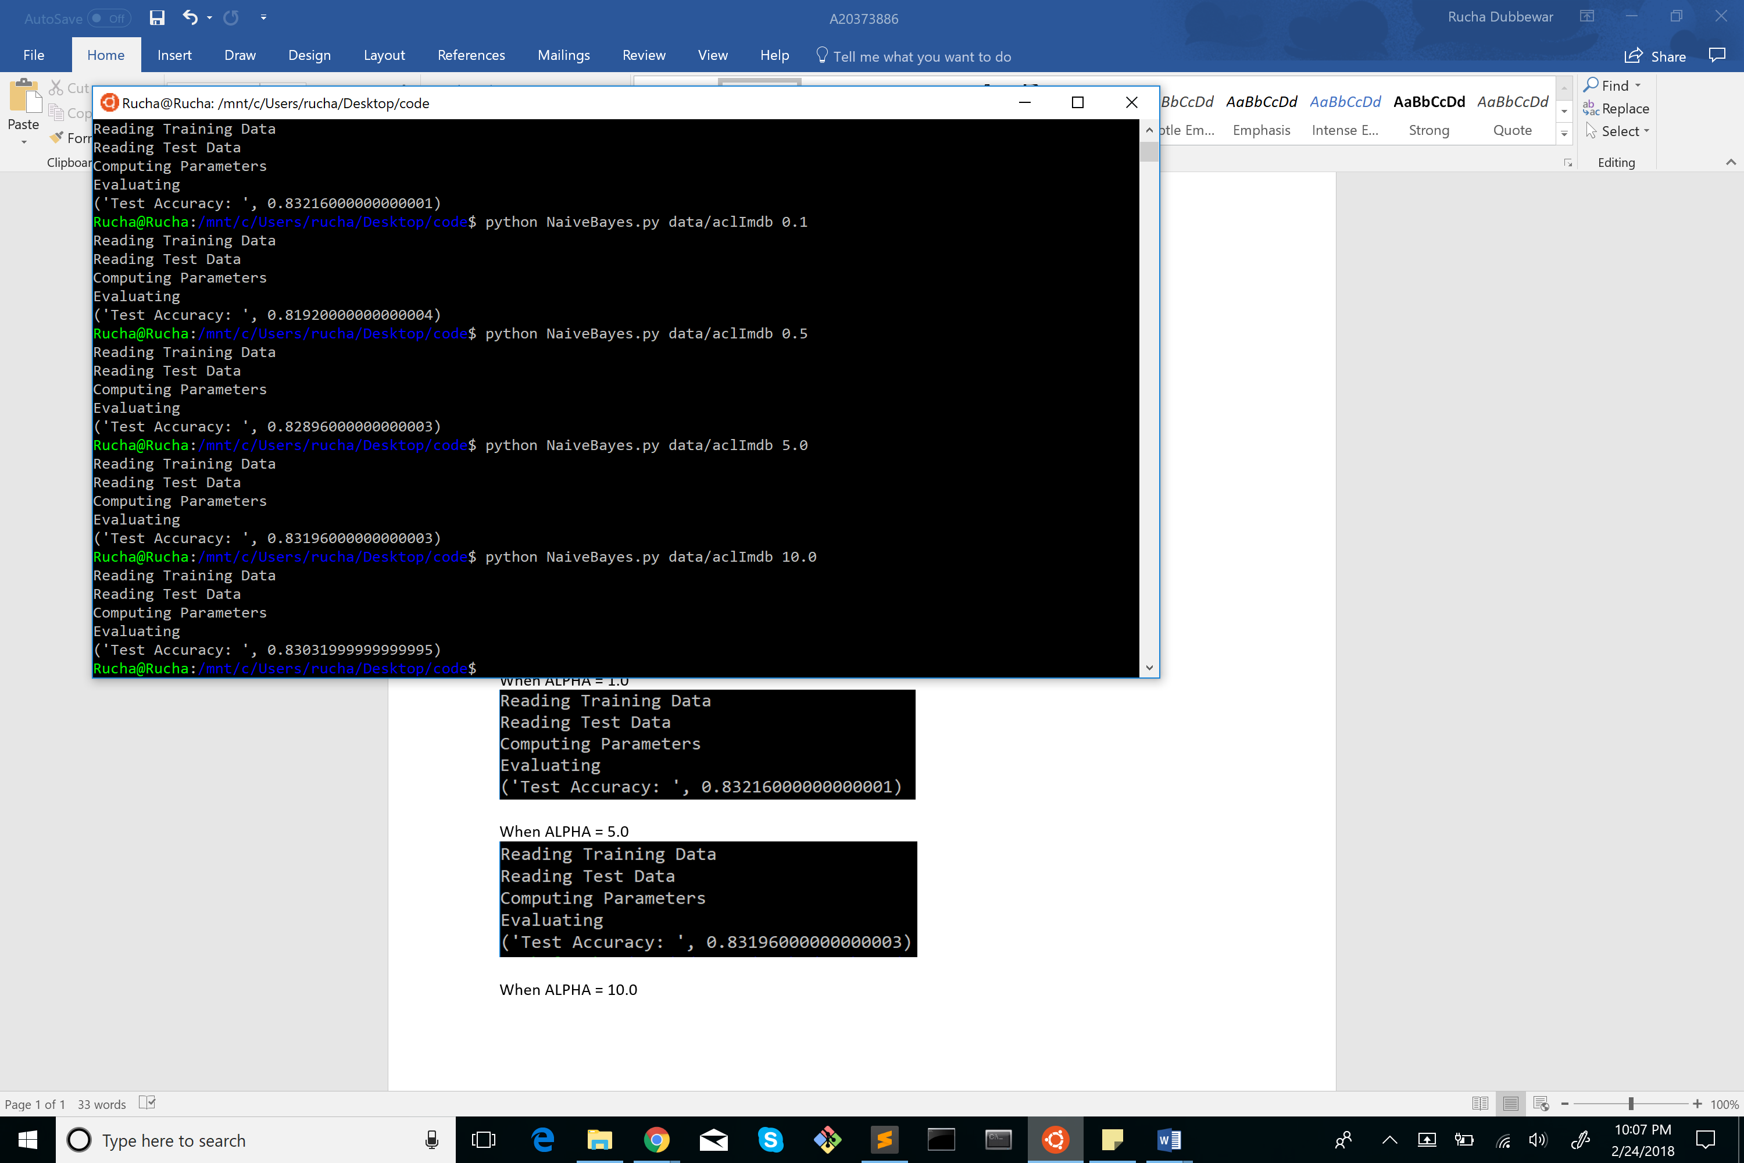

**Probability Prediction**

**Probabilities of first 10 reviews**

**When ALPHA = 0.1**

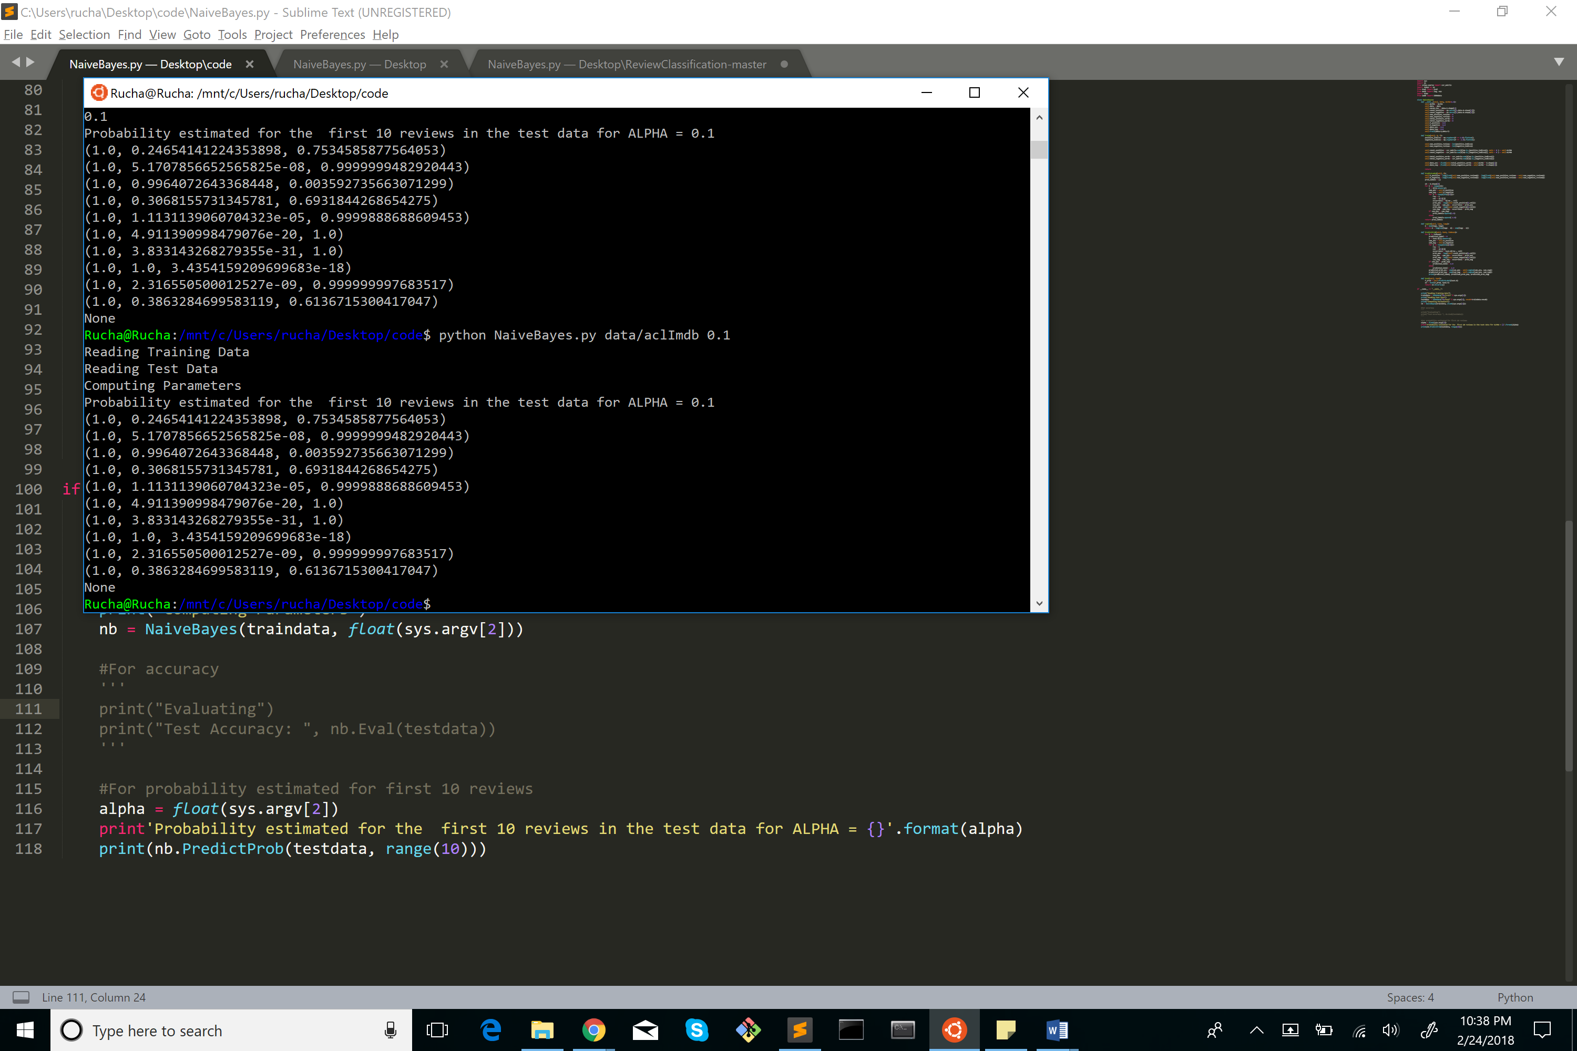

**When ALPHA = 0.5**

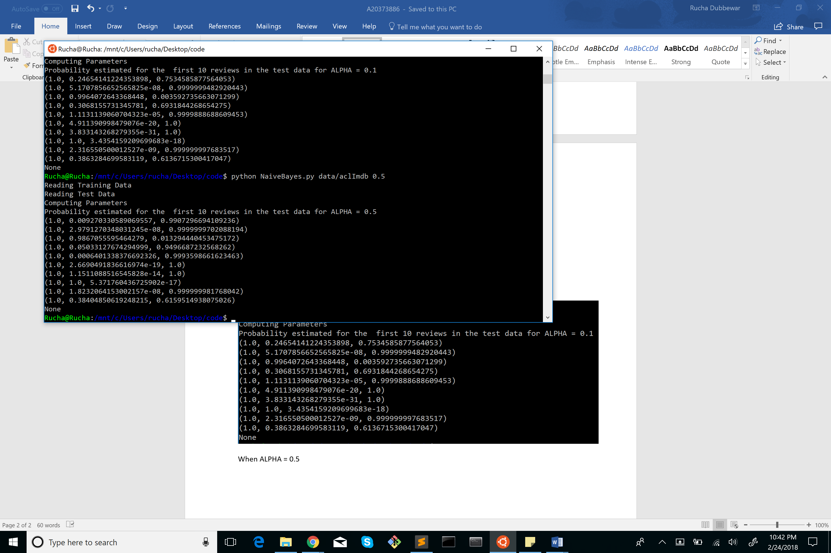

**When ALPHA = 1.0**



**When ALPHA = 5.0**

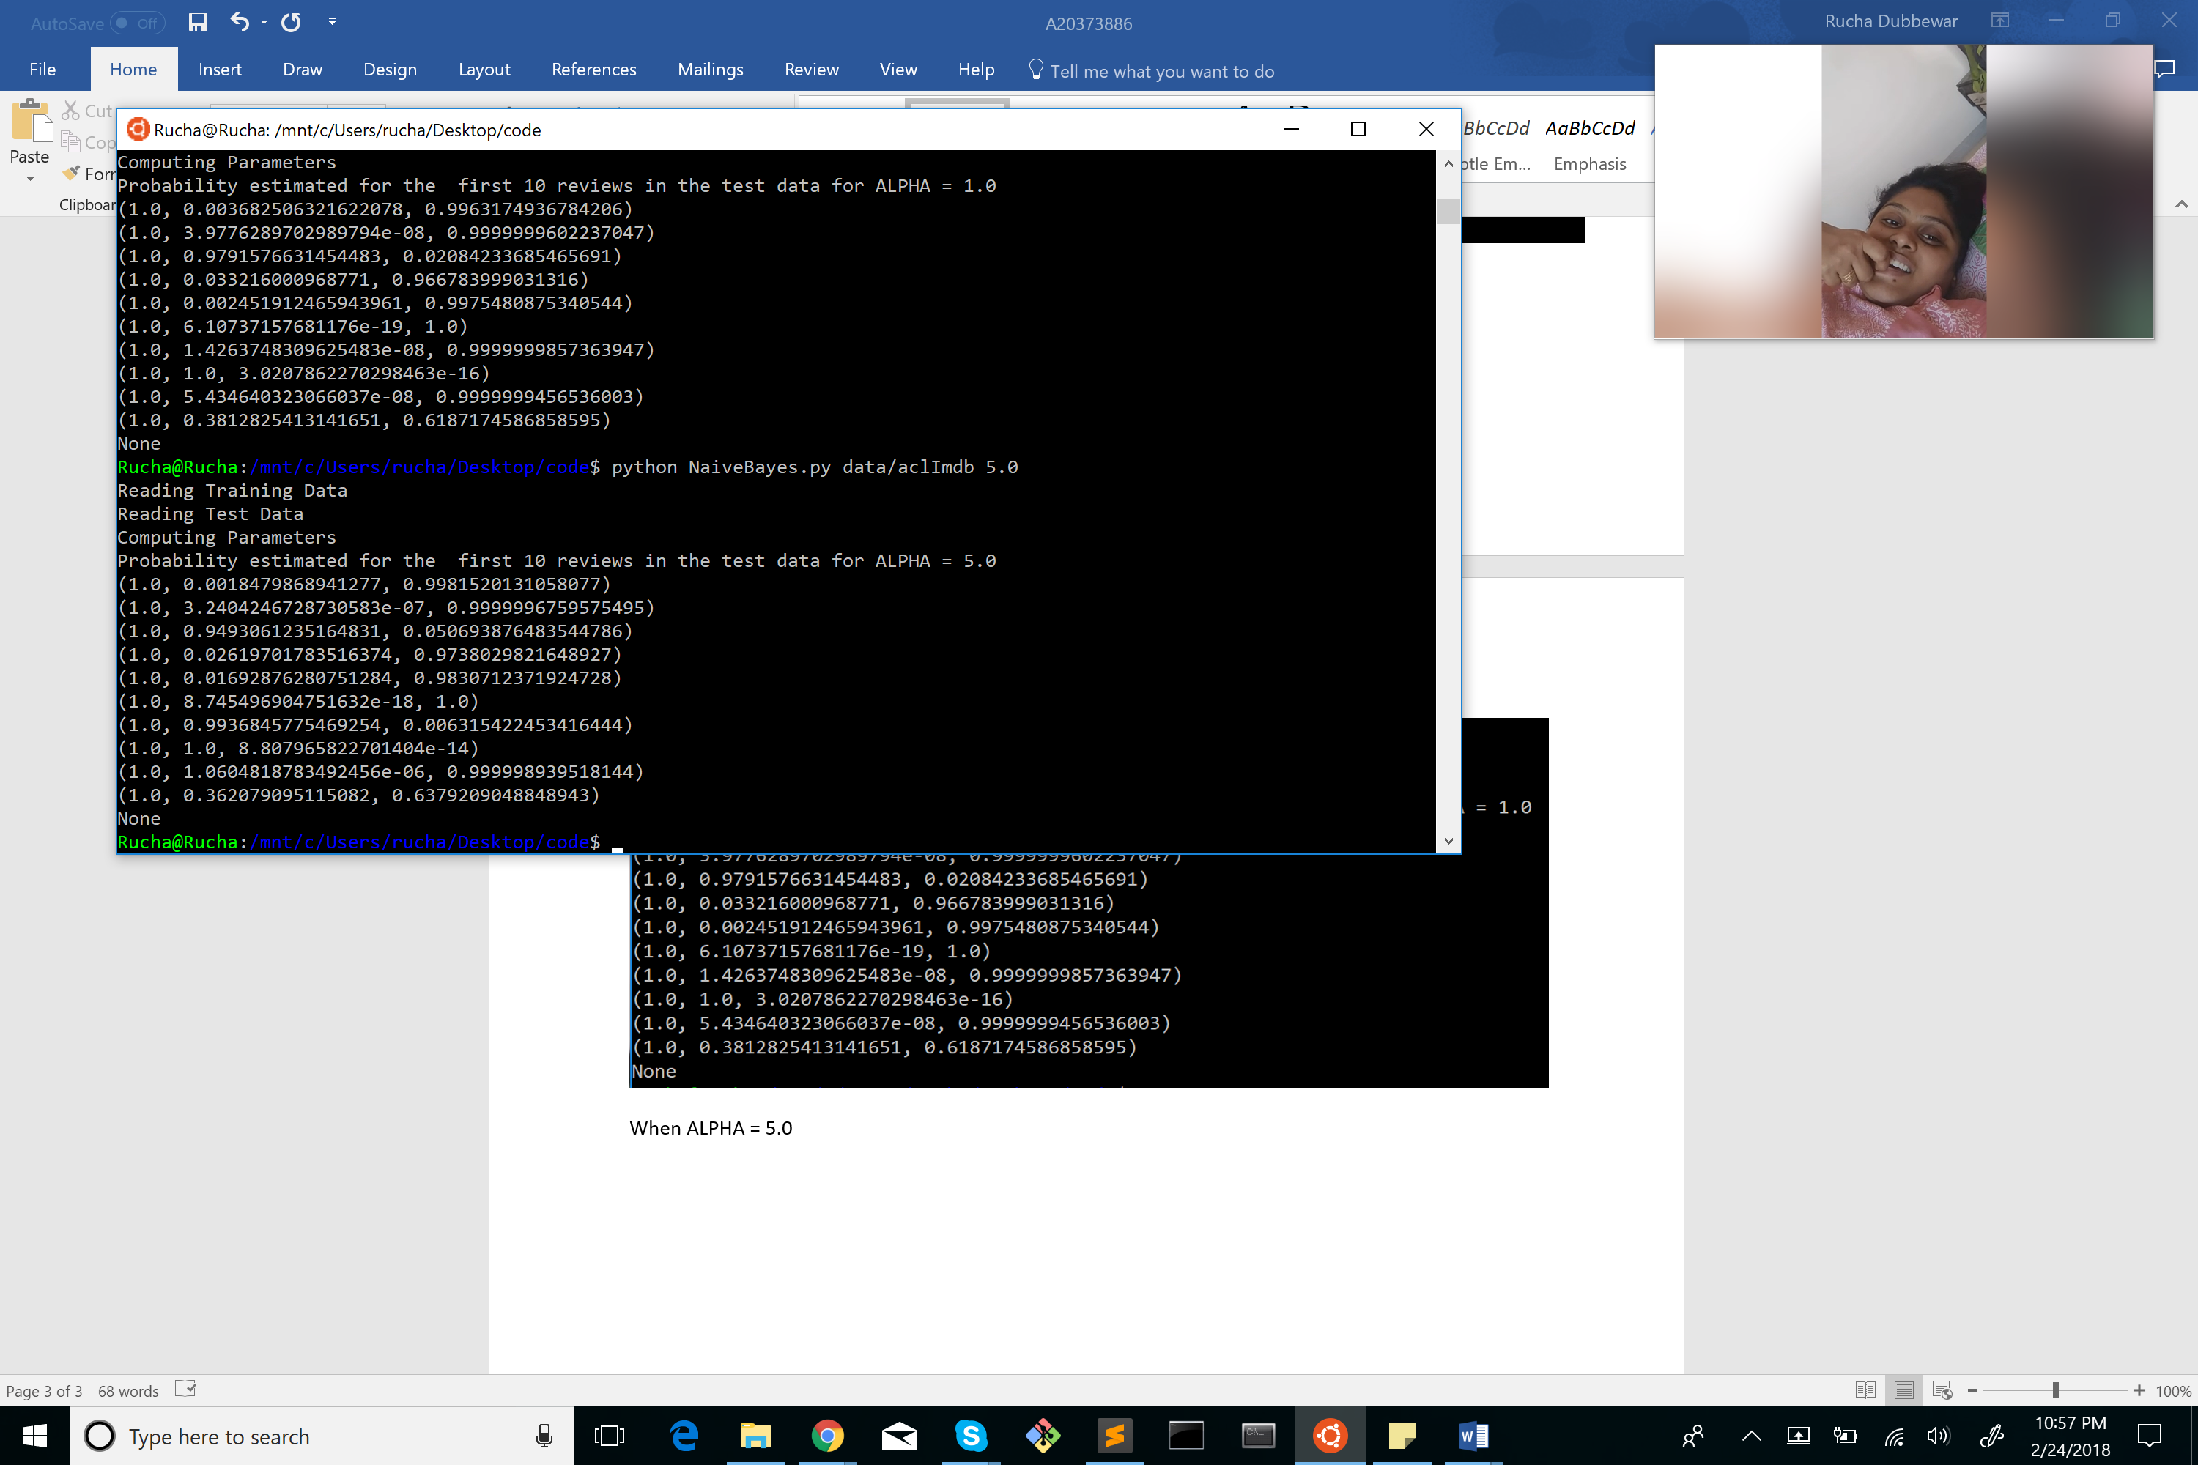

**When ALPHA = 10.0**

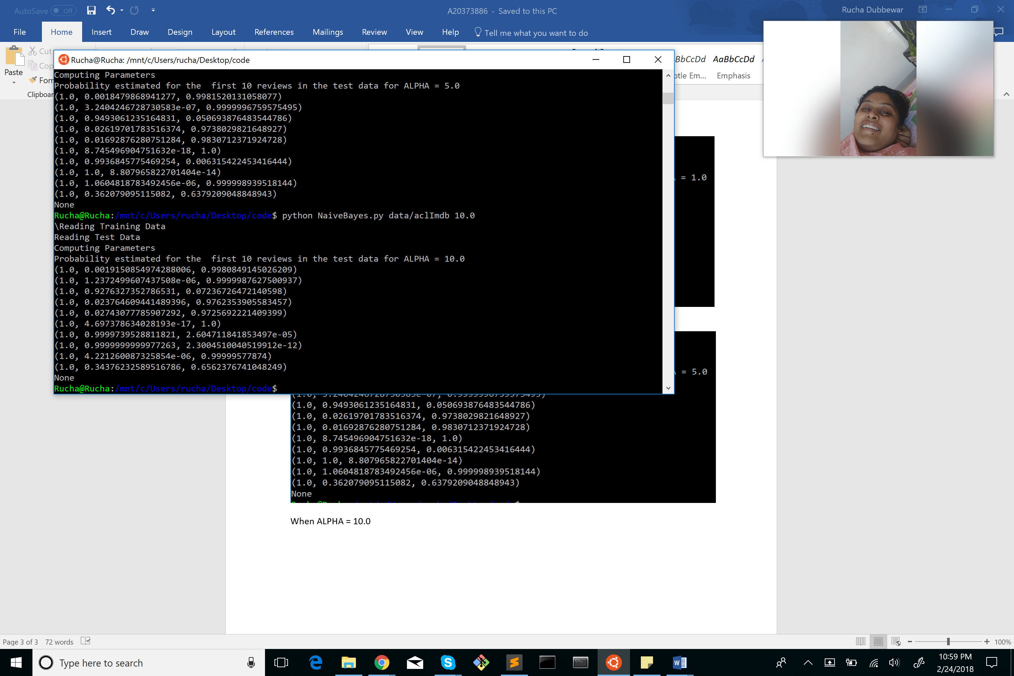

**Precision and Recall**

**Precision = 0.85**

**Recall = 0.77**

**Most 20 Positive and Negative words with their weights:**

